Solar Lantern

Made by:
Dhruv Joshi
Atheesh T.
Krishikesh Reddy
Reeyansh Shah

Mentor: Mrs. Malar
Table of Contents

- Project Synopsis
- Project Introduction
- Project BOQ
- Technical Specification Sheet
- Project Viability
- Project Application

Annexure:
Project Photos in Development Phase
Photos of Completed Solar Lantern

Project Synopsis

The project is developed to represent our school, Ryan International School, Nerul, at the CIDCO Science Exhibition.

We have developed the project in the area of ‘Renewable Energy Sources’. The type of renewable energy used is solar energy.

Our product name is ‘solar lantern’.

Project Introduction

Our project is a ‘solar lantern’. Please refer to the circuit diagram. We have the following main components:

- Solar Panel
- Battery
- LED Bank
- Solar Charge Controller

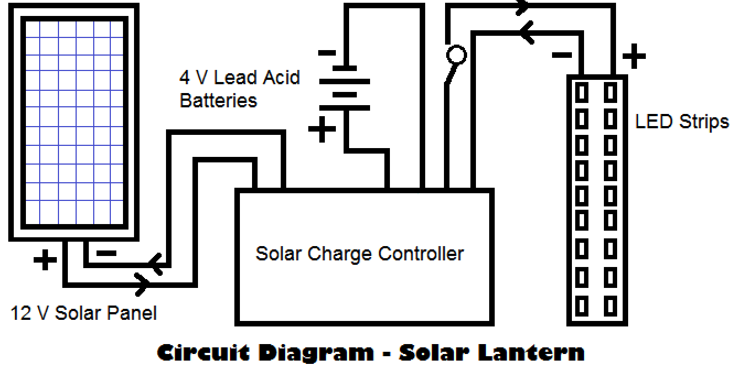
SN | Component | Qty. | Unit Price | Total Cost
1 | Solar Panel – 12 VDC  Make – SUNCA  Part No – PV-HY8002 | 1 No | 748 | 748
2 | Battery – 4V-2AH  Make – SUNCA  Part No - RB420E | 2 No | 184 | 368
3 | LED Bank - 4V  Make – NA  Part No – WU-DC-5730 | 4 No | 50 | 200
4 | Solar Charge Controller – 12 VDC  Make – Digitronix  Part No – SC 3A | 1 No | 280 | 280
5 | Switch – ON / OFF Switch  Make – NA  Part No - NA | 1 No | 10 | 10
6 | Wires – Black and White  1 Meter Each | Lot | 20 | 20
7 | Box | Lot | 320 | 320
8 | Paint | Lot | 80 | 80
 | Total |  |  | 2026
Project BOQ
All prices are in rupees (INR).

Technical Specification Sheet
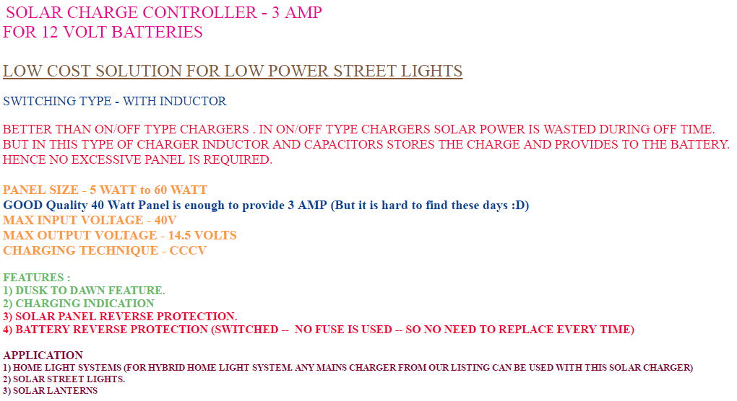
Solar Charge Controller

Technical Specification Sheet
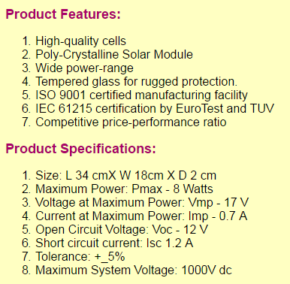
Solar Panel: 12VDC

Technical Specification Sheet
SUNCA Lead Acid Battery

Weight: 170.00g +5%
Product Code: SLA-4V-2Ah0-RB420E
Cycle use: 4.80V – 5.00V
Standby use: 4.50V – 4.60V
Max Charge Current: 0.45A

Technical Specification Sheet
LED Strip

Model: WU-DC-5730
Voltage: 4 VDC
Power: 35 mA
Chip: SMD-5730

Project Viability

Technical Viablility

LED Strip Power Consumption – 35 mA
Total No. of Strips – 4
Total Power Consumption – 140 mA
Battery Power Capacity – 2000 +2000 = 4000 mAh

Battery Life = 4000 / 140 = 28.57 hours

Considering usage of lantern for 6 hours a day, lantern can work for almost 5 days without charging.

In tropical countries like India, where sunlight is abundantly available, the lantern can meet the domestic requirements effectively.
Commercial Viability

The LED strip gives light intensity equivalent to 40 W incandescent lamp.

Considered electricity charges = 7.5 INR per unit (1 KW)
Cost of the lantern = 2000 INR (equivalent to 2000/7.5 = 266.6 units)
Power consumption by 40W incandescent lamp = 40/1000 = 0.04 KWh

So, number of hours of operation required for payback = 266.6/0.04 = 6666.66 hours

So, if solar lantern successfully operates for more than 6500 hours, it can pay back the investment cost.

As a project, all components are purchased as a single unit. Commercial development of product can bring competitiveness in supply cost, which will further reduce overall product cost, thereby making solar lantern commercially more viable.

Project Application

Solar lantern can be used effectively in the following sectors:

- As a housing application in rural areas.

- Street lighting.

- Housing societies in urban areas can use it as a common area lighting.

